Experiment No.: 01 Date: / /

Logic Gates
AIM: Verify the truth table of following logic gates:
a. AND OR and NOT
b. NAND, NOR, XOR and XNOR
c. realization of basic gates using universal gates

EQUIPMENTS & COMPONENTS:
- Digital Trainer Board
- ICs of Logic Gates
THEORY: A logic gate is a device that acts as a building block for digital circuits. They perform basic logical functions that are fundamental to digital circuits. A logic gate can be thought of like a light switch, where in one position the output is off (0), and in another, it is on (1). Logic gates are commonly used in integrated circuits (IC).Digital electronics relies on the actions of just seven types of logic gates, called AND, OR, NAND (Not AND), NOR (Not OR), XOR (Exclusive OR) XNOR (Exclusive NOR) and NOT. There are seven basic logic gates: AND, OR, XOR, NOT, NAND, NOR and XNOR. AND, OR, XOR are known as basic logic gates, NAND and NOR gates are known as Universal Gates and XOR and XNOR are known as special purpose gates. Table1 shows the symbolic representation of the logic gates and its IC numbers that are available from a number of manufacturers in standard families of integrated circuits.
Table 1
S. No. | Logic Gate | IC Number | Symbol
1 | NOT | 7404 | 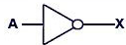
2 | AND | 7408 | 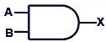
3 | OR | 7432 | 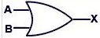
4 | NAND | 7400 | 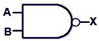
5 | NOR | 7402 | 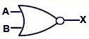
6 | XOR | 7486 | 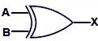
7 | XNOR | 74266 | 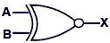

Part a:
- NOT Gate [7404]:
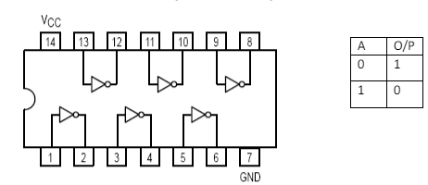
- 2 inputs AND Gate[7408]:
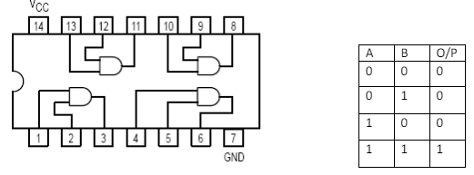
- 2 inputs OR Gate[7432]:
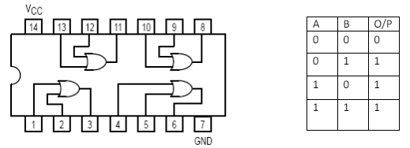
Part b:
- 2 inputs NAND Gate[7400]
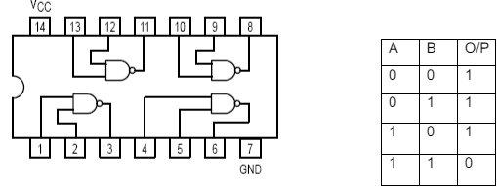

- 2 inputs NOR Gate[7402]
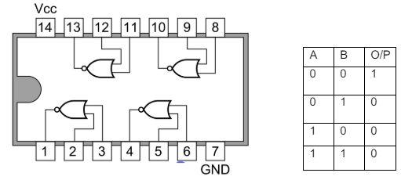
- 2 inputs XOR Gate [7486]:
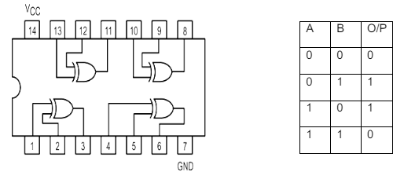
- 2 inputs XNOR Gate[IC 74266]:
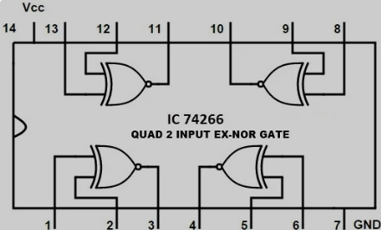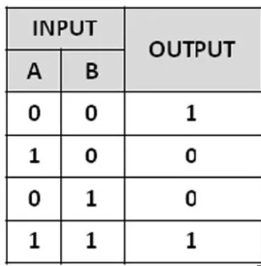
Part c: Realization of Basic Gates Using Universal Gates
NAND gate is actually a combination of two logic gates i.e. AND gate followed by NOT gate. So its output is complement of the output of an AND gate. This gate can have minimum two inputs. By using only NAND gates, we can realize all logic functions: AND, OR, NOT, Ex-OR, Ex-NOR, NOR. So this gate is also called as universal gate.
NOR gate is a combination of two logic gates: OR gate followed by NOT gate. So its output is complement of the output of an OR gate. This gate can have minimum two inputs, output is always one. By using only NOR gates, we can realize all logic functions: AND, OR, NOT, Ex-OR, Ex-NOR, NAND. So this gate is also called universal gate.
- OR gate using NAND Gate:
From DeMorgan’s theorems:
(A.B)’ = A’ + B’
(A’.B’)’ = A’’ + B’’ = A + B
So, give the inverted inputs to a NAND gate, obtain OR operation at output.
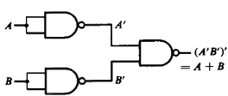
- AND gate using NAND Gate:
NAND produces complement of AND gate. So, if the output of a NAND gate is inverted, overall output will be that of an AND gate.
Y = ((A.B)’)’
Y = (A.B)
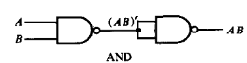
- OR gate using NOR gate:
A NOR produces complement of OR gate. So, if the output of a NOR gate is inverted, overall output will be that of an OR gate.
Y = ((A+B)’)’
Y = (A+B)
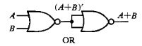
- AND gate using NOR gate:
From Demorgan’s theorems:
(A+B)’ = A’B’
(A’+B’)’ = A’’B’’ = AB
So, give the inverted inputs to a NOR gate, obtain AND operation at output.
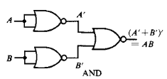

PROCEDURE:
- Place the IC on the Bread Board/Digital Trainer Board.
- Connect VCC and ground to respective pins of IC Trainer Kit.
- Connect the inputs to the input switches provided in the IC Trainer Kit.
- Connect the outputs to the switches of O/P LEDs,
- Apply various combinations of inputs according to the truth table and observe conditions of LEDs.

CONCLUSIONS:

Finite State Machine (FSM) Coding In VHDL
Let us consider below given state machine which is a “1011” overlapping sequence detector. Output becomes ‘1’ when sequence is detected in state S4 else it remains ‘0’ for other states.
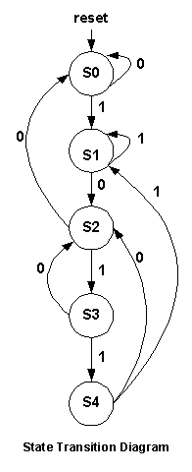

VHDL Code for FSM 1011-- using Moore Machine:
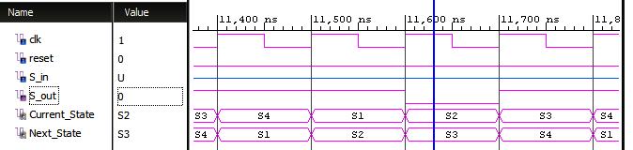

RTL Schematic of sequence detector for the sequence –1011-- using Moore Machine
